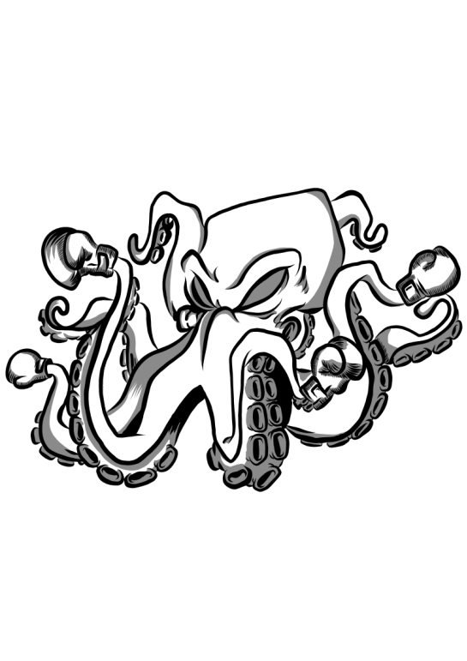
SUCKER PUNCH KICKBOXING
Accident and Incident Policy
Ratified 8th January 2024
Date for review: 8th January 2025
To be reviewed by: Tim and Emma Wise

Glossary of Terms:
SPK refers to Sucker Punch Kickboxing.
‘Staff’ refers to instructors, volunteers, freelance staff and any other person who may carry out work for or with SPK.
‘Working’ refers to any person who may do work with students, administration for or other support roles for SPK.
‘Administration’ refers to the member of staff responsible for document control and data management.
‘Workplace’ refers to locations where activities are held.
Contact information:
Designated Safeguarding Lead (DSL): BMABA
Email: emma.wise1985@gmail.com
Contact number: 07818277048

Deputy Designated Safeguarding Lead (DDSL): Tim Wise
suckerpunchkickboxing@gmail.com
Contact number: 07899922150

Any accident, incident or near miss should be discussed with either the Designated Safeguarding Lead (DSL) for SPK sessions or the Deputy Designated Safeguarding Lead (DDSL). The accident/incident/near miss must be discussed as soon as it is safe to do so and after all injured parties have received any medical attention required.
Details of any incidents that need to be passed on to RIDDOR will be dealt with by Tim Wise or Emma Wise along with the person who ran the session.
Any incident that triggers an incident or accident form to be completed will also need to be shared with the parents/carers.
First Aid kits
First Aid kit is kept on the wall by the door. It should be kept fully stocked and should be in line with advice given on your first aid course along with any National Governing Bodies advice as appropriate.

